**Design an online grocery shopping experience**

MujtabaAlboori(MA) James Doolan(JD)Manoj Kumar Reddy Bokku (MKRB)

Jin Shuttleworth(JS)Eorann Stafford(ES)

**1 Project introduction and Problem Statement (ES)**

**Problem Statement**

Our task as a group is to create an innovative new online grocery shopping experience for SuperPrice, a large chain store that has numerous out of town locations including large stores and smaller convenience stores. SuperPrice is located out of town; hence the company will need an efficient, user friendly online system to give customers the option of ordering their weekly grocery shopping and having it delivered to their door. This service is necessary for all large grocery stores nowadays as people find it hard to fit the weekly shop into their increasingly busy weekly routines.

**Initial Suggestions**

* Determine the interface that would best be suited to our target users. As a group we decided that people aged between 30 and 45 were most likely to avail of online grocery shopping. Due to routine, family life and working life they would find it harder to allocate time and visit a grocery store.
* Taking into account that our specific user group may not be as comfortable using an online application we must develop a user friendly, uncomplicated interface.
* Focus on vivid imagery including high quality HD examples of the food items available for purchase, making the application more appealing to potential users.
* Take care that the layout and columns on the homepage are concise and to the point allowing for easy navigation through the application.
* Provide a help option for users who need to speak to a supermarket employee in relation to any issues that may arise.
* We will utilise ‘research orientated design’ as a process within HCI to gather data from our users and eventually build two separate personas that we could test the early drafts of our system on (Forlizzi, Zimmerman, & Evenson, 2008).

**2 Requirements gathering**

**2.1 Users group (JS, ES)**

Using interviews personal experience and observation, we narrowed down the design to online grocery shopping experience rather than general supermarket shopping. Previous research recorded about online grocery shopping suggested majority online shoppers are younger than 55 years old and female, with an annual income of over 70000 USD (Morganosky & Cude, 2000, 2002). We then decided to look at the user group as: 30-50 year old professional women living with a family.

**2.2 The goals of data gathering (JS)**

* To identify who the primary users of online grocery shopping are;
* To find out their attitudes to online grocery shopping;
* To investigate their in-shop shopping habits;
* To understand their preferences within online grocery shopping;

(Morganosky & Cude, 2000, 2002)

**2.3 Online survey ( ES JS)**

Previous online shopping research pointed out that time saving, convenience and added services from the online shops are the main potential reasons that encourage users to shop online (Huang & Oppewal, 2006; Morganosky & Cude, 2000, 2002). We therefore developed two online surveys to reach the goals of our data gathering. We selected seven users to conduct the two surveys. Although there are many debates about online research methods (Berry, 2005; Rogers, Preece, & Sharp, 2011), online research does have remarkable advantages, e.g. time saving, low cost and fast response, it is then very much suitable for this pilot design project. The two online surveys were developed on Surveymonkey. The survey was delivered through emails to the users.

* **Survey 1- Users' grocery shopping habits (appendix 1)**
* **Survey 2- Users' attitudes to online shopping (appendix 2)**

**3 Summary of survey results (JS)**

**3.1**  **Respondents:** Seven users all submitted their online answers to the survey. Their ages ranged between 30 and 50. Among them, 42.86% are between 30-35, 42.86% are between 36-40 and 14.29% are 45 and above. All of the surveyees/respondents are living with families, 85% of their families have 2-4 people, 42.88% of them work full time and 57.14% work part-time. All the surveyees have online shopping experience although some of them have stopped shopping online.

**3.2 The main reasons for ceasing to shop online are:**

* 55% surveyees don't think it saves time when compared to in-shop shopping.
* 55% surveyees claimed they spend more time figuring out how to use the online shopping system.
* 50% surveyees couldn't get a shop assistant to help if they had a problem.
* 50% surveyees felt online shopping is not as easy as physically being in a shop.
* 40% surveyees found it is not easy to locate the goods.
* 40% surveyees are dissatisfied with the quality of goods.

**3.3 42% of the surveyees are continuously shopping online and they rated the advantages as:**

* can do it any time of the day I want: rated 2.67 in 5;
* the quality of delivered goods is fairly good: rated 2.67 in 5;
* can get refund if the items are not good quality: rated 2.67 in 5;
* have time to make the correct choices and decisions: rated 2.67 in 5;
* can do it any time of the day I want: rated 2.33;
* know how much I have spent: rated 2.33;
* can shop on my PC, tablet or mobile phone: rated 2;
* More choice than in-shop shopping: rated 2.

**3.4 The surveyees sequence of online product ordering was:**

* fruits/vegetables
* Dairy products
* Meat/poultry
* House hold goods
* Frozen products
* Health & beauty products
* Others
* Soft drinks
* Children products
* Baking products

**3.5 The surveyees suggestions for improving an online shopping system:**

* keep a record of my previous shopping list: 3.57 in 5
* more detailed information for each product: 2.57 in 5
* real time chat for help: 2.43
* special entries for weekly family shopping: 2.33
* speed up the mobile phone shopping application: 2.33
* rate the health benefits of certain products:

3.6 **Time slot for in-shop grocery shopping**

* 57% during the weekend;
* 43% after work in the evening.

**3.7 Time spent by surveyees on their weekly in-shop grocery shopping**

* 29% under 1 hour;
* 57% between 1-2 hours;
* 15% between 3-4 hours

**3.8 Where do you usually do your in-shop grocery shopping?**

* 57% in supermarket;
* 43% shop in all different shops-local community shop, supermarket or any type of shops

**3.9 Do you enjoy in-shop grocery shopping?**

* 43% yes;
* 57% no.

**3.10 If you do enjoy doing in-shop grocery shopping, which aspect is most enjoyable for you?**

* I can pick up anything I like

**3.11 What do you least enjoy about in-shop grocery shopping?**

* Time consuming
* Parking difficulties
* Waiting for the check out

**4 Field Observations**

Human decision making is specific to particular situations and environments (Häubl & Trifts, 2000). A form of ethnographical research was essential to observe customers and how they behaved while in a supermarket (Dix, Finlay, D. Abowd, & Beale, 2004).

The field observation took place in a familiar German supermarket chain on a Saturday afternoon for two hours. While spending time observing people in a store, a number of instances occurred that would warrant further consideration.

**Firstly**, the order in which people buy their required items is in many ways controlled by the layout of the store. Customers will walk in and usually follow a specific circuit around the shop; the only time they deviate is if they have forgotten something. We in our online model will have to devise a fluid category system that resembles the various isles within a grocery store.

**The Second** observation is that being able to touch and feel items plays a major role in how people shop. Customers are always picking up various items. The sensory experience of shopping in a grocery store will have to be taken into account when we design our online model. How will we compensate for the customers inability to touch and feel and make online shopping a viable option?

**Lastly**, people like to ask for help. If they have a problem they find the nearest member of staff and expect to have their issues resolved on the spot. We will have to provide a help feature in our design to provide any additional support that a customer may require.

Customers get agitated whilst in the queue. Their demeanour changes gradually as time passes in line. This is important because our online service will remove the need for people to stand in line and hopefully provide a stress free alternative for potential customers.

**Key aspects of observation**

* We must try to capture the feel of individual food isles to make the experience more natural for the customer.
* We must compensate for the customers inability to use all their senses while shopping online, touch, feel, smell etc.
* Provide a help option in our online design for customers queries.

**5 Data analysis**

**5.1** **Our survey results drew two main conclusions re online user scenarios:**

**5.1.1 Time saving scenario**: users who have children and work full time prefer to use online grocery shopping as it can save them a great deal of time, enabling them to play with children and care for their family. Their needs for the online shopping system are: 1) access flexibility--applicable to smart phone and tablet etc; 2) efficient, easy to use interface-they want a special entrance for weekly shoppers; 3) a memory function that can retain their previous shopping list.

**5.1.2 Virtual as real online shopping experience scenario**- the users in this scenario are mainly a couple without children, they work and study at the same time, they may not possess a car. They usually shop in the local grocery store and are very concerned about the quality of the food products. They therefore don’t feel confident about the guarantee of the quality of online shopping products and they intend to hold back in their attitudes towards the online grocery shopping. They are also not familiar with the online grocery shopping system. To persuade these users to online shop, we need to: 1) provide an online shopping experience which mimics the in-shop experience; it will include high definition photos of the food products; navigating online shopping in the same manner as people do the in-shop shopping; detailed information for each product, including nutrition information and health indicator; multiple choices for each product, such as ripeness, size, expired date, etc; 2) provide a user friendly interface for online shopping system, e.g. simple but logical tags, easy navigation to products, multi-search tools-search by key words, by picture, by brand, by price, by usage; 3) online alive help-chat, users can get live help when they have difficulties.

**5.2 Persona/ scenarios (JS)**

Based on the results of the surveys two personas were developed as below.

Fiona McDonald: I love online grocery shopping, I like the idea of having access to it anytime and anywhere which will make my shopping time more flexible. It should be easily accessed via smart phone, tablet and other electronic devices. This means that I can do it while on the bus or waiting for my kids at their sports events, etc.

37 years old, has two children, age 2 and age 5. Fiona works full time (9-5) in a university library. She is very skilful in computing and online searching. Fiona has done lots of shopping online for her family. She is very glad to hear SuperPrice is going to launch the online grocery shopping.



(Morganosky & Cude, 2002; Trav, 2011)

**Ideal Features**

* Can be accessed via PC, tablet, smart phone and other electronic devices
* Remembers my previous shopping list
* Online help
* Special entrance for weekly shopping customers
* Detailed information of the goods
* Multiple searching tools, e.g. search by keywords, name, picture of the products, price, brand, etc
* Provide more health options

**Frustrations**

* The network speed is slow when using mobile phone
* Spend too much time on shopping although online shopping has shortened the procedure
* Sometimes it is difficult to find a product online shopping
* There is not alive help online when you need a help in your online shopping procedure
* The details of the products are not clear, some of them are confusing.

**Needs**

* To be able shopping online anywhere at anytime
* To use as less as it could be for grocery shopping
* To be able getting helps online when there is a problem in online shopping procedure
* To be able getting advices for weekly food shopping in term of health and price
* To be able ensure the quality of the goods and getting the refund if there is a quality problem.



**Rachel Kelly:** I enjoy in-shop grocery shopping where I can pick up the goods I like but it is sometimes very time consuming and waiting at the checkout is very frustrating. I have some online shopping experience but mainly with clothes and house hold products. As for grocery shopping online, I am quite concerned about the quality of the food. Can they pick out fruit and veg as good as I could? Also how do I know that the food products are good quality without seeing and feeling them?

Rachel is 32 years old, living with her partner. She works part-time as a receptionist in the hospital and at the same time she is studying to be a graduate programme in university. Rachel doesn’t drive, she does her grocery shopping mostly in her local shop, but she feels the expense of daily foods is sometimes too high. She is glad to know there will be an online shopping option in SuperPrice as she can shop in this supermarket to reduce her spending in future.

(Rathke, 2013)

**Needs**

* Same shopping experience as in-shop, e.g. shopping sequence, can see and feel the quality of food product
* Trustworthy quality of the food products and guaranty of a refund procedure
* Detailed information of the products, e. g. high definition picture of the products, health indicators
* Easy to navigate online interface, simple but effective search engine.
* An easily accessible 1 to 1 help feature

**Frustrations**

* Not easy to find the products I want, spend more time than in shop shopping
* Unreliable quality of the food products
* Cause more trouble if the quality is not as good as I expected, refund process is too complicated
* Can’t recognise and advances in online grocery shopping

**Ideal Features**

* Easy to access
* Shopping experience should be the same as in-shop shopping
* Guaranty that the quality of my shopping goods are as good as picked up by myself
* Details of the information including ingredients and health indicator
* Reviews of the products to help make the choice

(Ooi, 2013)

**6 Lo-fi Prototyping**

Lo-fi (lo fidelity) prototypes are used for planning and building the websites with low investment. This is achieved by using low-cost materials such as cardboard sheets, charts, papers, stickers etc. By assembling all these materials, we can develop a relatively complex model of the interface easily and quickly. We can then use this model to demonstrate the workflow of the website to users, obtain feedback from the users, and it also helps concretise our ideas i.e. shows us what elements need to be altered and which work well in the design.

Using a lo-fi prototype to develop a user-centred design has the following advantages:

* We can expect honest feedback from users of by seeing the lo-fi design.
* Cost of making changes in lo-fi is much cheaper compared to hi-fi
* Observe how users are interacting with the design rather than the visual style in the website
* Modifying the design is easy in the lo-fi
* It is easy for programmers to develop a hi-fi prototype using the lo-fi design

**6.1 Lo-Fi Development**

We used hand-drawn representations of the interface on A4 paper, which was a fast and effective method for conveying ideas of how our design could be laid out. For example, at one of our meetings, when an issue was raised about a submenu structure, it was easy to sketch out a diagram of the structure, which could then be thrown out for discussion.

As mentioned previously, the results of our surveys showed that the most important factor for users with respect to their online shopping experience was that it "should be as close as possible to shopping in a real store". Our users want to be able to examine the products closely, find out about the nutritional information of food, and have the products arranged in a way that is as close to the layout of a store as possible. In addition, our survey subjects also raised the point that, in a shop, one can ask a staff member if they cannot find what they are looking for.

Another key factor for users was "getting a personalised experience". Our first persona (Fiona) mentions the site being "memorable to [her] previous shopping list". In producing this prototype, we incorporated facilities that enable the user to create shopping lists, and save baskets and meal plans.

With these factors in mind, we made several decisions at the outset:

* The interface is displayed on a single page, with no need to scroll up or down. We felt that this would make the site more user-friendly and keep the interface uncluttered. In addition, this style of interface would allow for consistency between the desktop and tablet versions of the site.
* Large, high-quality photographs are to be used throughout the site, giving users the opportunity to inspect the goods as they would in-store. Also, we must give the users an option to check the nutritional value of an item without impeding the shopping process.
* The interface must include a chat feature in a prominent location, making it easy for the users to contact staff members.

In this project, we produced two lo-fi prototypes; the second is a development on the ideas presented in the first.

**6.1.1 Lo-Fi Prototype 1**

Each category is explored with a mouse over to the submenu item list then it displays the total list of items present in the store ,When user click on the item or search for the product in the multi search option, Total list of specifications is displayed in a table format consisting of price in the local currency and the nutritional values present in the product so that user can self-examine about their health condition and compare the products of similar range and choose the product which fits to their health condition. After selecting the product upon their interest they will be redirected to basket list and popup window displays with check out option and continue shopping and there is an option of adding number of quantities user requires and proceed to the final check out they may add to favourites of their basket list it will be easy to pick the items in the next session login, there is an option of auto pick up for the selected items by selecting the weekday and time of delivery of the products, proceeding to the payment there are couple of options available auto payment and general payment, In auto payment is done automatically once after storing the credentials in the user account and after completing the check out a window displaying about the congrats your order is successfully placed with some credit points user might feel excited by earning some credits.

Step1) This is the home page of the website includes Header sidebar content bar and footer consist of the contact and support related information

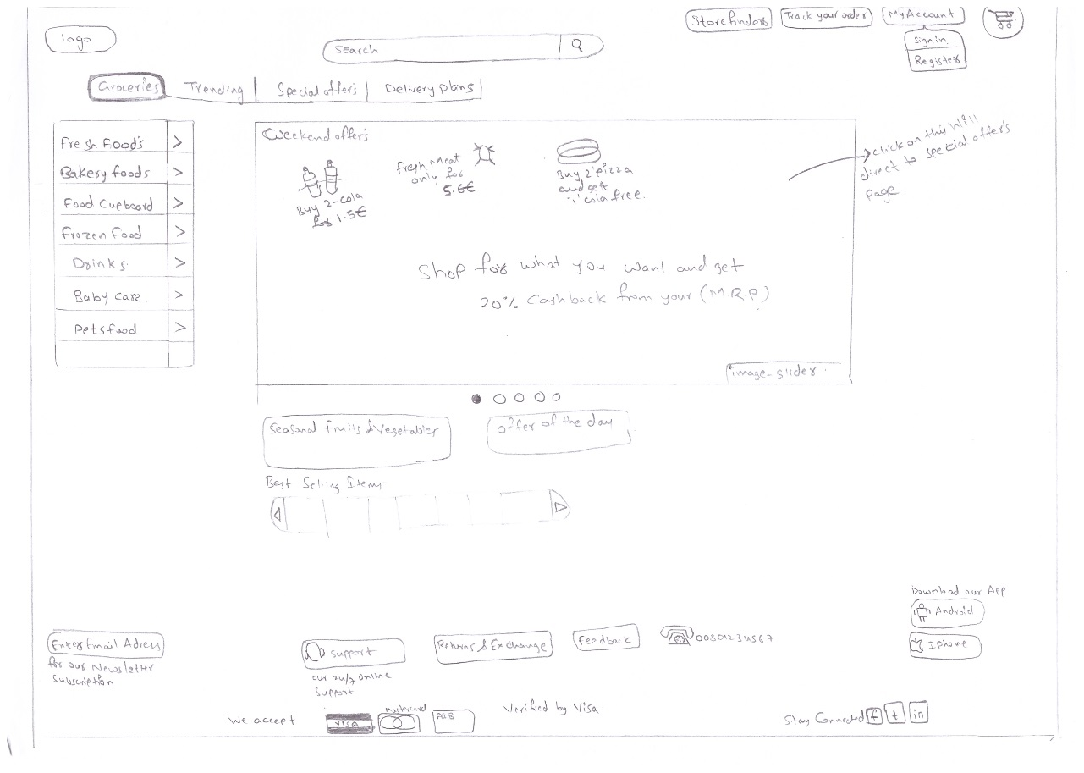

Fig.1.0 Home page

**Step 2)**

In this page it consists of how the submenu is working when the mouse over to the category or item It displays the results with some filter options so that user can filter the particular product by checking and unchecking the categories.

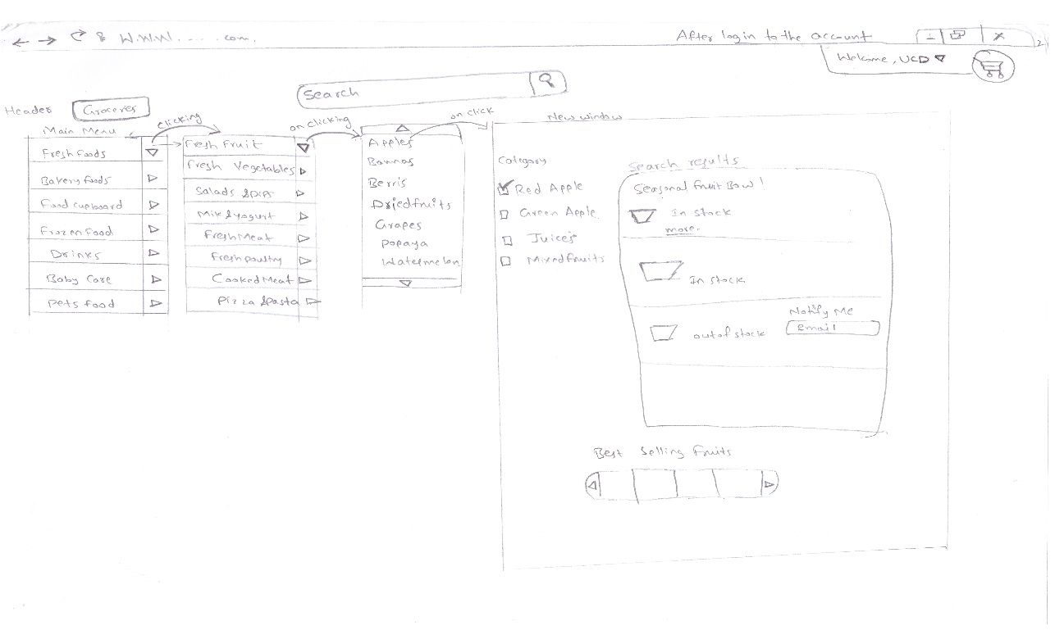Fig 2 Submenu Working

**Step 3:**

In this page contains it consists of the short description of the products which were about the product is selected from the searching based on search results such as it displays the product description and the nutritional values of present in the product and buttons displaying the add to the basket option with the quantity selection

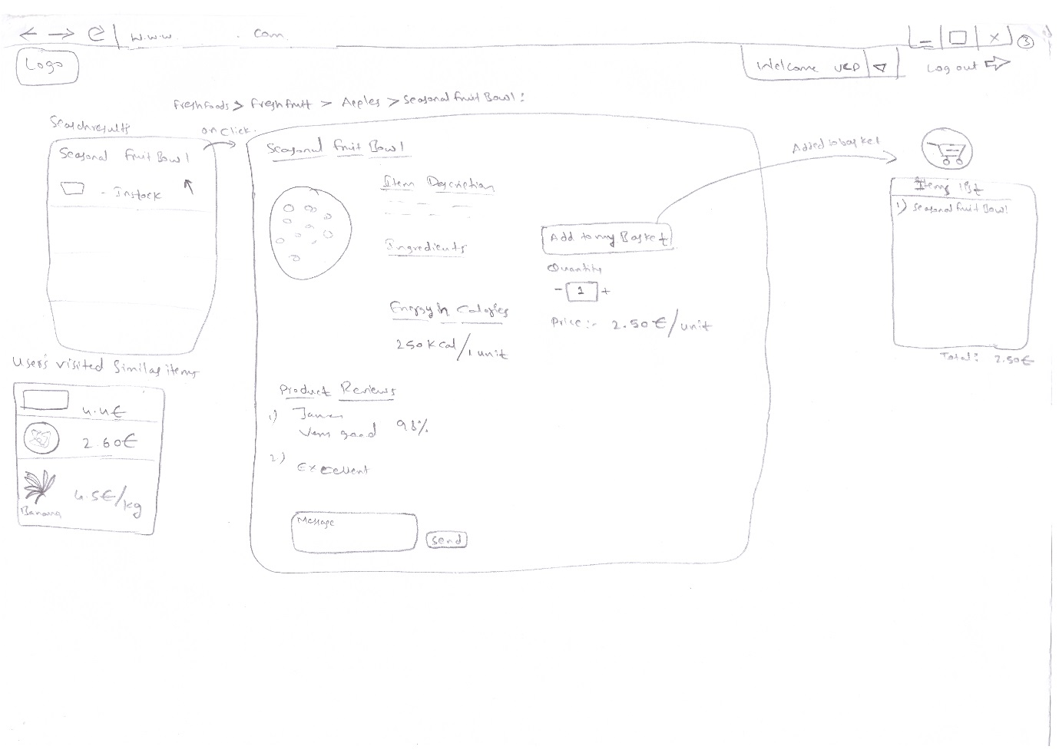

Fig 3 .0 Product description

**Step 4)**

This is the final step after selecting the product it will be redirected to the basket checklist and payment section, Here there is an option called auto pick up by selecting the groceries which are useful for the weekly basis by selecting the products and selecting the time and weekday of the delivery of the products ,There are two types of payments auto payment normal payment auto payment is used for auto pick up of goods the user needs to confirm the auto pickup order by replying yes /no option with the SMS sent by the grocery store so that order is placed.

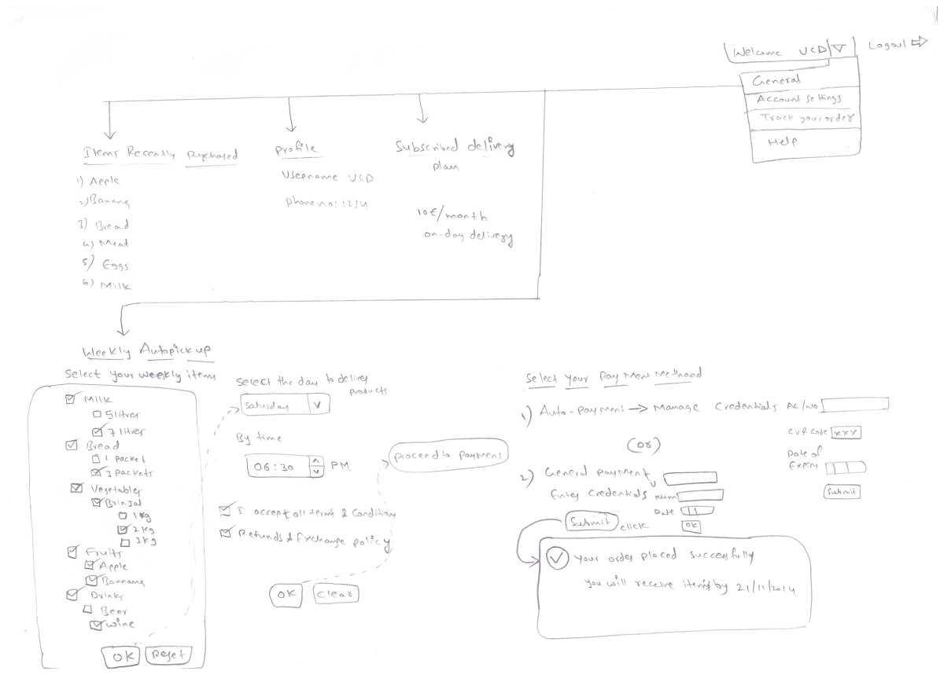

Fig 4.0 Auto Pick up and auto payment

**Lo-fi 2**

The second iteration of our lo-fi design consists of most of the same elements as the first, with a more fine-grained approach to the page elements (interactions, placement, size etc.). The first prototype also enabled us to concretise our ideas about how the interface would be laid out. With this in mind, I will briefly define some of the terms I will use to describe the various elements. See the image below for the lo-fi representation of the layout of our interface.

**[Image Slider]**: A large central area on which the products will be displayed; can be navigated using arrow buttons on either side.

**[Navigation Panel:]** A context-sensitive menu situated to the right of the image slider, which acts as a filter on the products displayed.

**[Context Bar:]** A bar displayed above the image slider which controls the context of the navigation panel.

**[Product Tiles:]** Products are displayed in "tiles" on the image slider; each tile contains a high-quality photograph, option buttons, and product information.

[**Facility Panel:**] Contains facilities such as a basket viewer and search bar. Also contains buttons for viewing the user's account details, delivery information, payment details etc.

********IMAGE - Basic Layout

**Interface Element Detail**

Here we present a detailed account of the various design elements, and give an example use case for each.

**Context Bar**

As mentioned previously, the context bar manages coarse-grained navigation of the site; it controls the context of the navigation panel. This bar contains a "Shop" context, which will display the default navigation panel with the various shopping departments (Fruit, Bakery, Butcher etc.). The other contexts are: "Seasonal Offers" (season-specific deals such as Christmas, Hallowe'en, BBQ-related goods in the summer, etc.), "Deals" (Buy-One-Get-One-Free, Combination Deals, etc.), and "Favourites" (saved baskets, regular purchases, meal plans). The context selected can be further refined using the navigation panel as before. See Figure 1 for example navigation contexts.

******** IMAGE - Context Bar

**Navigation Panel**

The menu displayed on the navigation panel will be sensitive to mouse-over and clicks; a mouse-over produces a submenu to the right, and a click will filter the results shown in the image slider. An example of this behaviour is represented in the image below

We decided that the maximum "level" of a submenu should not be greater than three; less would not allow enough refinement of results, and more would be frustrating, cluttered, and difficult to navigate. This menu contains the various product sections (Fruit and Vegetables, Bakery, Frozen Goods, etc.) For example, upon selecting "Fruit \& Vegetables" in the navigation panel, fruit and vegetables will be displayed on the image slider. In addition, the panel will also contain submenus, accessed upon mouse-over, which can refine the user's search further. To continue the previous example, upon mousing over "Fruit \& Vegetables", a submenu will pop up with entries such as "Fruit", "Vegetables", "Pre-packed Salads" and the like. See Table 2 for an example of the submenu system for the "Shop" context.

This style of navigation makes it fast and easy to find an item, and satisfies our design criteria of providing an experience similar to a real store.

******** IMAGE - Nav Panel

**Image Slider**

This is the central element in our design; it contains all the products relevant to the context selected in the context bar and navigation panel. The slider, as its name suggests, displays the products in a scrollable panel, navigable by using arrow buttons on either side. In the touchscreen version of the site, the slider can be operated by swiping.

Two ideas were suggested for the layout of the slider:

Having virtual reality "shelves" when viewing a particular shop department; for example, in the "Fruit" section, the slider could show baskets and boxes of fruit as they would appear in the shop.

Simply filtering the items as the sections are selected on the navigation panel.

These ideas were pitched to our users, and their responses can be seen in REF: Response section.

A possible issue with this system would be a trade-off between the size of tiles on the slider vs. the number of tiles to display; if too many items are displayed, the tiles will be too small to take full advantage of the high-quality photos and the display will be cluttered, whereas too few tiles will make the slider frustrating to navigate. To combat this, users will be given the option to select the number of tiles; the default will be 8, with options to show 12 and 16 tiles.

******** IMAGE- Image Slider

**Product Tiles**

The product tiles consist of two sections, an upper pane on which a high-quality photograph of the product is displayed, and an information pane below. The image below shows our lo-fi version of a tile.

This panel contains two tabs for food items, one displaying pricing information and one showing nutritional information. For non-food items, the nutritional information tab is absent. For simplicity, we decided that the pricing should be displayed as a list; for example, when viewing apples, prices are displayed for individual apples, 4-packs and 6-packs. This eliminates a problem we found with other shopping websites, where it can be difficult to find the desired quantity.

The inclusion of a high-quality photo satisfies our design goal of allowing users to inspect the goods' quality, while the nutrition panel allows users to assess the health benefits of the products easily. Many other shopping sites allow a similar inspection of nutritional information, but they redirect the user to another page. The tab system on our item tiles allows users to continue shopping after checking an item, and they can also compare items by opening the nutrition tab on several tiles.

The upper section will also contain several buttons for navigation. A "View Similar Items" button will filter the image slider to only show similar items; for example, if the user is in the Off-Licence section and they click this button on the Guinness tile, the image slider will only show stouts. A "Recipes" button would bring up a list of suggested recipes using the item as an ingredient, and the user can then select the other items in the recipe from the image slider. This recipe system can be seen in REF: Recipe Figure.

******** IMAGE - Product Tile

**Facility Panel**

Consists of button bar, with various options available to the user. The lo-fi version of this element can be seen in REF: Figure 5. The panel will be an accordion-style menu, where selection of an entry in the menu makes that selection "take over" the panel. This behaviour is also documented in REF: Figure 5.

This style of menu allows users to enter payment and delivery details "on-the-go", without the need to sign in first, which in turn enables them to finish the primary task at hand (selecting goods). After checkout, the user will then have the opportunity to set up an account with the details they provided, giving them access to facilities like saved baskets and meal plans.

******** IMAGE - Facility Panel

* 1. Usability testing and summary of the lo-fi prototypes
     1. storyboard usability testing**(MKRB, JD)**

**Storyboard for the LO-FI 1)**

**4.2.2 Users interviewed Re: Lo-fi 1.**

The following are some of the user reactions to the lo-fi drawings of the online shopping system. We wanted their opinions on the proposed layout and user features of the system. To recognise the need for privacy they will simply be called User A and User B.

**User A**

*‘The basic layout of the homepage looks very user friendly which would encourage me to use the service. If I find an app or website hard to navigate or too cluttered, it tends to put me off using it and I look for another option’*

*‘Providing a HD quality image of the product that I am looking at would encourage me to buy it as long as it is the same quality product I receive upon delivery’*

*‘I would not pay much attention to the nutritional content if it were attached to a certain product, I already know that an apple is healthy and that chocolate is not’*

*‘In the payment details section I prefer that my card details are not kept on file, I just enter them as I go’*

**User B**

*'I like the basic layout of the homepage, first impressions are critical to whether I use a service or not’*

*‘I like the chat feature as it would allow me to get help if I should need to while using the service’*

*‘The recipes feature would be very nice but it may cause me to go off on a tangent and start thinking of recipes when I am really there to do my grocery shopping which can be a hard task as is’*

*‘Virtual reality shelves would make the app very appealing visually as most online shopping websites that I have visited are dull and lifeless, not a good environment in which to choose your weekly food purchases’*

**7 Hi-Fi Prototyping (MA)-finish by 7th Nov**

Hi-Fi (high-fidelity) prototype is more realistic prototype to the final product than Lo-Fi prototype. The user should be able to interact with the design like one would in a real product. Hi-Fi development can be time consuming task and require extensive programming skills and expertise unlike Lo-Fi prototype which do not require programming skills. Lo-Fi prototype is useful to test the initial idea before wasting time developing the actual product.

**7.1 Development**

The Hi-Fi design was focused on implementing the last draft of the Lo-Fi. The Lo-Fi User’s evaluation has been taken into to account in creating this Hi-Fi prototype. The design was built using modern HTML tools to be flexible and work on multiplatform and different screen size. We have chosen an HTML based as prototype because it will be more realistic for the user to test the online shop in real environment where it will be mostly used rather than trying to simulating the online shop. This will allow to understand the user interaction better and exploit implementation issue. Lo-Fi prototype usually does not consider how the functionality is implemented in the system so developer will be difficult to implement and usually results in duct-tape solution which often confusing to the user and does not work nicely with the working environment. Therefore, it is better to catch these issue early and make the prototype in the same environment. This has resulted in several changes in the Lo-Fi which will be explained later in details.

First, we begin to design the main component of the Hi-Fi prototype. The design consist of the top bar, context bar, side navigation, and facility panel. We have integrated the context bar with top bar in the Hi-Fi. These components will visible and accessible to help users navigate and interact with the online shop.

From the top, the context bar helps the user to quickly switch between regular shops, seasonal shop. This allows the user to quickly find seasonal item without wasting time navigating the main shop menu. Offer section lets the user find the item on offer in the store so the user can save money and time. Favourite section enables the user to keep his favourite items in one place so the user does not have to search for it.

7.1.1 Home Page

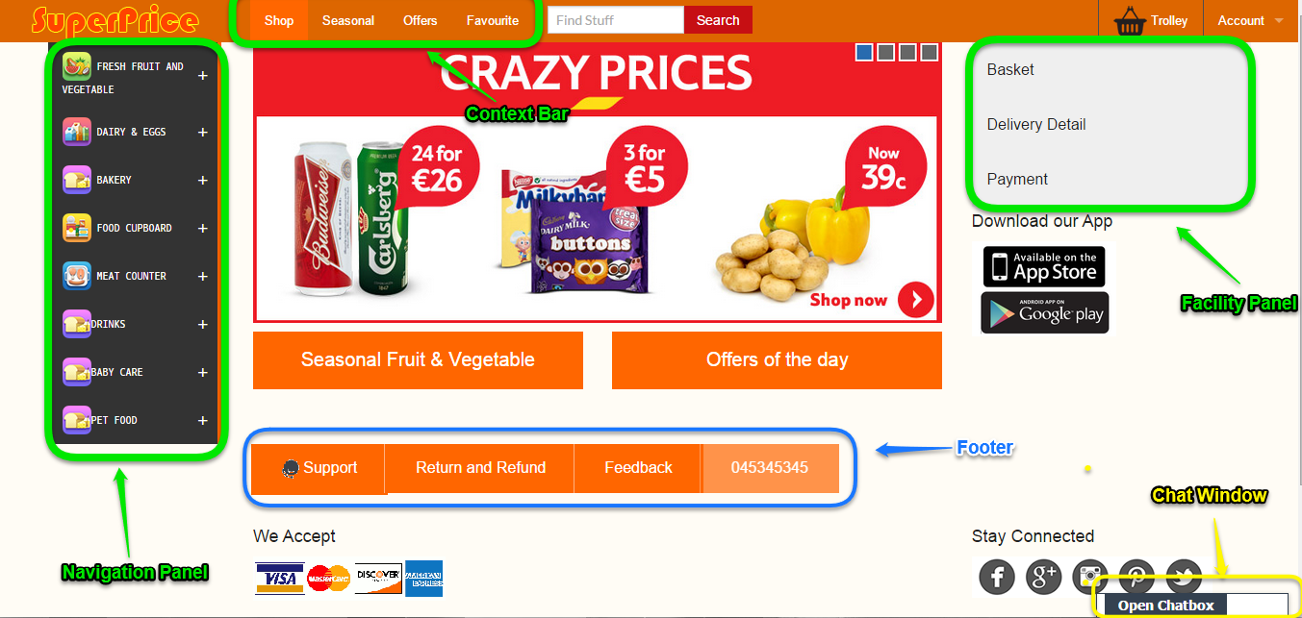

Figure 1 :Home Page

Top bar is consist of SuperPrice’s logo, context bar, search field, basket, and account section.



Figure 2 : Top Bar

The footer side of the page provides general information for the user. User can click on support to get help with any issue. Information on return and refund can be found once the user clicks on “Return and Refund” button. Users are encourage to leave feedback so we can improve and fix any issue. There is a phone number so user can easily contact for help directly. The social media section allows users to follow and keep in touch with SuperPrice’s news. This helps SuperPrice to engage with its customer.

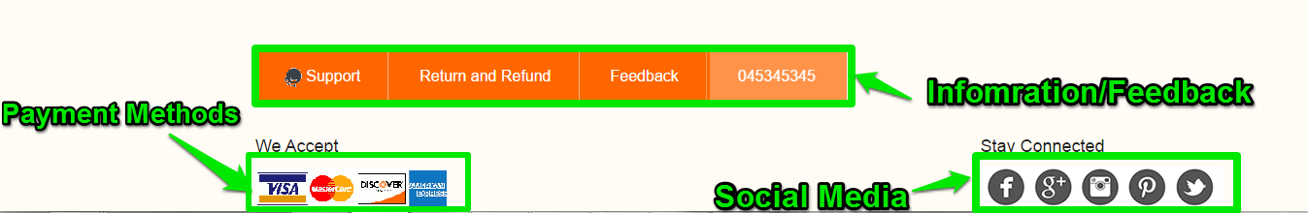

Figure 3: Footer

Side navigation menu allows user to easily filter the shop items. The menu is divided into categories similar to SuperPrice’s aisles map so user who have shopped at SuperPrice know where their favourite items. The user can hover his mouse on the category, and the menu will display more subcategories. In touch devices, user can click since there is no mouse.

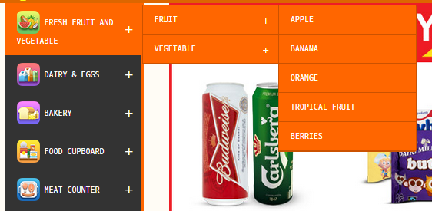

Figure 4: Side Navigation Menu

**Facility Panel**

Facility panel contains three elements; basket, Delivery detail, and payment. We have decide to remove the chat element and move to different place because chat/support is not part of the ordering process which can confusion for the user.

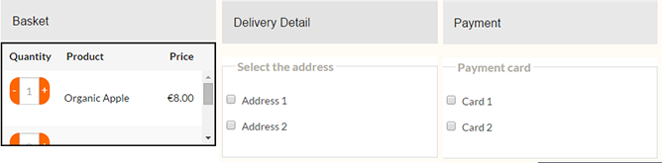

Figure 5:Facility Panel

When user navigate through the side menu and click on section, the browser will direct him to page. The page will display all the relevant items. The items are arranged in grid of three columns.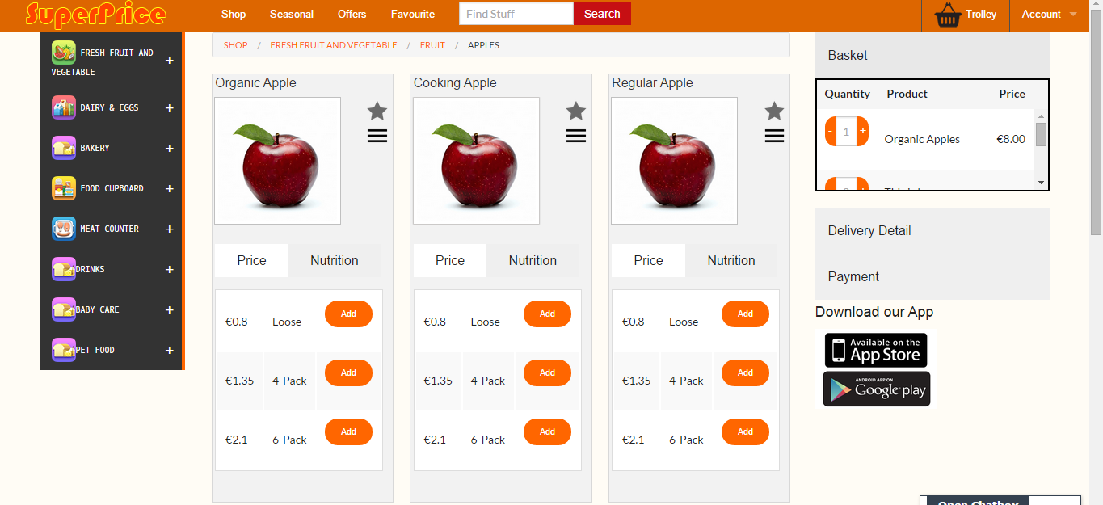

Figure 6: Apples Section

Each item contains information about the price, nutrition and image of the product. Also, there are actions that enable user to put the item in the favorite, add the item to usual, view similar items, and view recipe that the item can be used. User can click on the price tab to view the prices for specific quantity and add the item to the basket.

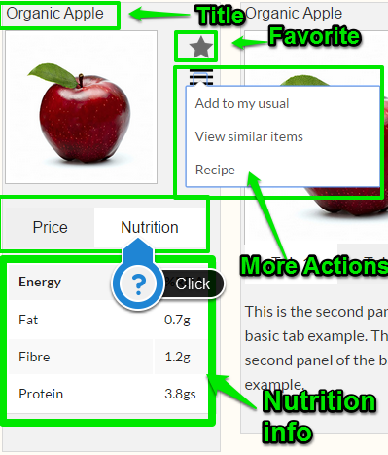

Figure 7: Items

**8 Evaluation of the design (JS, ES, MKRB)- finish by 12th Nov**

User experience (UX) is “dynamic, contextual dependent and subjective, which stems from a broad range of potential benefits users may derive from a product” (Law, Roto, Hassenzahl, Vermeeren, & Kort, 2009, p. 727). It is about how users feel a product; the feeling includes usability, pleasure, satisfaction, and their overall impression of how usable the product is (Rogers et al., 2011). It is the emotive, positive feeling of the user which is contextual. Some researches described it as “enjoyment, hedonic, aesthetics, engagement” (Bargas-Avila & Hornbæk, 2011). Previous research identified the relationship between usability and aesthetics as ”strong usability manipulation combined with a medium to large aesthetics manipulation” and “the user's affective experience with the usability of the shop might serve as a mediator variable within the aesthetics usability relation “(Tuch, Roth, Hornbæk, Opwis, & Bargas-Avila, 2012, p. 1) Chen et al (2005) using Nielsen’s ten heuristics developed criteria for evaluating the interfaces of online shopping systems. Their research suggested that heuristics usability and evaluation identifies the most usability problems.  To evaluate our hi-fi design, we then developed two questionnaires that employed Nielsen’s ten heuristics evaluation (table 1) and interpretation of the users’ experience.

**8.1 The evaluation procedure**

**8.1.1 Task-based inspection:** Using our two scenarios, we chose four users from our target users group and split them up into two groups.

* **group1 (scenario 1)** – using smart phone to select ten products (user can complete the task by tracing previous shopping list or just select);

1. fat free milk (1L),
2. organic bananas(loose);
3. Lean steaks;
4. brie cheese;
5. free range eggs;
6. cherry tomatoes;
7. cooking apples(package);
8. mushrooms(loose);
9. smoke salmon(package) ;
10. wholemeal bread loaf

* **Table 1 Nielsen’s ten heuristics (Chen & Macredie, 2005, p. 519)**
* **Heuristics Explanations**
* H1: Visibility of system status The system should always keep user informed about what is going on by providing appropriate feedback within reasonable time
* H2: Match between system and the real world The system should speak the user’s language, with words, phrases and concepts familiar to the user, rather than
* system-oriented terms. Follow real-world conventions, making information appear in a natural and logical order
* H3: User control and freedom Users should be free to develop their own strategies, select and sequence tasks, and undo and redo activities that they have
* done, rather than having the system do these for them
* H4: Consistency and standards Users should not have to wonder whether different words, situations, or actions mean the same thing and the system should
* follow platform conventions
* H5: Error prevention Even better than good error messages is a careful design, which prevents a problem from occurring in the first place
* H6: Recognition rather than recall Make objects, actions, and options visible. The users should not have to remember information from one part of the dialogue
* to another. Instructions for use of the system should be visible or easily retrievable whenever appropriate
* H7: Flexibility and efficiency of use Allow users to tailor frequent actions. Provide alternative means of access and operation for users who differ from the ‘‘average’’
* user (e.g., physical or cognitive ability, culture, language, etc.)
* H8: Aesthetic and minimalist design Dialogues should not contain information that is irrelevant or rarely needed. Every extraunit of information in a dialogue
* competes with the relevant units of information and diminishes their relative visibility
* H9: Help users recognise, diagnose and recover from errors Error messages should precisely indicate the problem and constructively suggest a solution. They should
* be expressed in plain language
* H10: Help and documentation Even though it is better if the system can be used without documentation, it may be necessary to provide help and documentation.
* Any such information should be easy to search, focused on the user’s task, list concrete steps to be carried out, and not
* be too large
* **Group 2: Scenario 2**

In scenario 2, the Hi-Fi model is put to the test by the same users that helped us to evaluate the Lo-Fi model. The task for group two is to locate the items that we provided in the list as well as the customer help function using a personal computer.

**User A: comments**

*‘I found the finished model to be easy on the eye for a start. I was able to locate the various items on the list quite easily and I found the help feature. The only thing I would say is that help is labelled support and not help but I found it easily enough. Overall I found the system very easy to use’.*

**User B: comments**

*‘I found each item off the list in very little time. I thought the colour scheme used on the site was very good. Everything was clearly labelled and the fact that the first thing I saw were HD images of fruit, made me realise that I would be comfortable buying groceries from the store’*.

**Conclusion**

The task of getting each user to find certain items on our Hi-Fi system was a success. The two users found the items quickly and complemented both the visual display and the overall layout of the page. The only one glitch was that the help feature was labelled support. This did not in any way prevent either user from finding the tab but they both commented on it not being labelled help or maybe customer support. Overall the user evaluation of the proposed Hi-Fi was a successful experiment and has shown that the design is at the very least, user friendly.

**8.1.2 Online survey:** users are asked to conduct two online surveys regarding their experiences in the task and the experiences in total interaction

We use Surveymonkey as an online tool to conduct our surveys. The questionnaires are combining closed questions and semi-open questions with five rating scales.

**8.1.2.1 Group 1 users’ online survey results- reflection of the needs from scenario one**

**a) The results of ten heuristics questionnaire of Superprice online shopping system are as shown as table 2 and fig. 1.**

# Table 2 Results of ten heuristics questionnaire of Superprice online shopping system

|  |  |  |  |  |  |  |  |  |
| --- | --- | --- | --- | --- | --- | --- | --- | --- |
|  | **extremely agree** | **agree** | **neutral** | **disagree** | **extremely disagree** | **yes** | **no** |  |
| **Q1** |  | 2 |  |  |  |  |  |  |
| **Q2** |  | 1 | 1 |  |  |  |  |  |
| **Q3** |  |  |  |  |  | 1 | 1 |  |
| **Q4** |  | 2 |  |  |  |  |  |  |
| **Q5** |  |  |  |  |  |  | 2 |  |
| **Q6** |  |  |  |  |  | 1 | 1 |  |
| **Q7** |  | 1 | 1 |  |  |  |  |  |
| **Q8** |  |  |  |  |  | 1 | 1 |  |
| **Q9** |  | 2 |  |  |  |  |  |  |
| **Q10** |  |  |  |  |  | 1 | 1 |  |

# Q1 (semi-open question with 5 scales) User can easily determine where they are and what options are available

# Q2 Task/menu choices are presented in a logical order(semi-open question with 5 scales)

# Q3 (closed question) The system allows the user to easily navigate back through the menu system

# Q4 (semi-open question with 5 scales) The various interfaces are consistent throughout

# Q5 (closed question) An error message appears when a mistake is made

# Q6 (closed question) The system has default information to prevent errors

# Q7 (semi-open question with 5 scales) The use of vivid colour makes for a pleasurable visual experience

# Q8 (closed question) User can select their products by looking back at previous shopping list

* Q9 (semi-open question with 5 scales) Different items are well illustrated
* Q10 (closed question) There is an online help option available

**Fig. 1** Results of ten heuristics questionnaire of Superprice online shopping system

**b) The results of UX questionnaire of Superprice online shopping** (all the questions are semi-open question with 5 scales) are shown as table 3 and fig. 2.

**Table 3** Results of UX questionnaire of Superprice online shopping

|  |  |  |  |  |  |
| --- | --- | --- | --- | --- | --- |
|  | **extremely agree** | **agree** | **neutral** | **disagree** | **extremely disagree** |
| Q1 |  | 1 | 1 |  |  |
| Q2 |  | 1 | 1 |  |  |
| Q3 |  | 1 | 1 |  |  |
| Q4 |  | 1 | 1 |  |  |
| Q5 |  |  |  | 2 |  |
| Q6 |  |  | 2 |  |  |
| Q7 |  |  | 1 | 1 |  |
| Q8 |  | 1 | 1 |  |  |

* Q1 Overall, it was an enjoyable experience to shop online at Superprice-
* Q2 Overall, I was happy with the interface of the Superprice online shopping system-
* Q3 I feel relaxed and in control when using the online system
* Q4 I felt engaged & interested when I did the online shopping
* Q5 I am satisfied with the overall functionality of the Superprice online shopping system
* Q6 It is easy to navigate through the system-100% neutral
* Q7 I feel confident that if I need customer support, a Superprice agent will speak to me
* Q8 I feel secure while using the online payment system

**Fig. 2** Results of UX questionnaire of Superprice online shopping

**8.1.2.2 Analysis of group 1 users’ online survey results**

**a) Ten heuristics questionnaire of Superprice online shopping system- usability analysis**

Nielsen’s ten heuristics were used to evaluate the usability of the online shopping systems with very positive research results. (Chen & Macredie, 2005), we thus developed questionnaire by interpreting Nielsen’s ten heuristics into our local context. The survey results show users are generally happy with the visibility of online system, consistency/standards and aesthetic aspect of the design which reflected as 100% agree to the question 1, 4 and 9; whereas users were partially agree or hold back their opinion to the questions 2,3,6,7,8 and 10, they are respectively are: match between system and real world, user control and freedom, recognition rather than recall, flexibility and efficiency and help & documentation. However, users are not happy with Q5 which reflecting the error prevention. (table 2, fig. 1)

**b) UX questionnaire of Superprice online shopping system- UX analysis**

There are not very positive feedbacks in UX survey as shown in table 3 and fig.2. Users partially agree to Q1,2,3,4 and 8 meanwhile holding back their opinion to these questions and Q6, however, they disagree with Q5 and partially disagree with Q7. The results indicate our users are not sure their experience is enjoyable, the interface of the system is good, they are in control and engaged when using the system and the system is secure; they are not satisfied with the whole function of the system and don’t feel have a strong customer support.

**c) Limitation of our evaluation**

UX evaluation is a big and complicated topic/area, it is also a growing area too. Researchers in this area have many debates on the evaluation models, values, the scale of the measurement, even the definition of hedonic- there many different approaches, e.g. cognitive, psychological, social aspect, etc (Attfield, Kazai, Lalmas, & Piwowarski, 2011; Diefenbach, Kolb, & Hassenzahl, 2014). Therefore, our evaluation here is far too basic and simple for this task. Although we tried to make a sense of our evaluation with theory and previous research methods, we didn’t really have time to standardise the validity and reliability of our evaluation. There are some inevitable limitations here: our questionnaires need to be tested and more accurate in term of define users’ experiences; our samples are far too small to draw any conclusion.

**7 Conclusion**

In conclusion, working with users closely is a time consuming yet essential part of designing a system for commercial use. Through close collaboration with our user groups we were able to come together as a group and roughly put together a system that we believe fulfilled their varying needs. The fact that each user has different needs meant that our system, in its early stages, went through various modifications based on information collected from our surveys and interviews. We believe that we have designed an efficient system that meets all the criteria that would be required by a large grocery chain like SuperPrice.

**References:**

Dix, A., Finlay, J., D. Abowd, G., & Beale, R. (2004). *Human-Computer Interaction .* Essex: Pearson Education Limited.

Forlizzi, J., Zimmerman, J., & Evenson, S. (2008). Crafting a Place for Interaction Design Research in HCI. *Design Issues*, 19-29.

Häubl, G., & Trifts, V. (2000). Consumer Decision Making in Online Shopping Environments: The Effects of Interactive Decision Aids. *Marketing*

*Science*, 4-21.

Attfield, S., Kazai, G., Lalmas, M., & Piwowarski, B. (2011). *Towards a science of user engagement (Position Paper).* Paper presented at the WSDM Workshop on User Modelling for Web Applications.

Bargas-Avila, J. A., & Hornbæk, K. (2011). *Old wine in new bottles or novel challenges: a critical analysis of empirical studies of user experience.* Paper presented at the Proceedings of the SIGCHI Conference on Human Factors in Computing Systems.

Berry, R. M. (2005). Web-based Survey Research: Lessons from the University of Akron Study. *International Journal of Public Administration, 28*(1-2), 57-72. doi: 10.1081/PAD-200044562

Chen, S. Y., & Macredie, R. D. (2005). The assessment of usability of electronic shopping: A heuristic evaluation. *International Journal of Information Management, 25*(6), 516-532.

Diefenbach, S., Kolb, N., & Hassenzahl, M. (2014). *The'hedonic'in human-computer interaction: history, contributions, and future research directions.* Paper presented at the Proceedings of the 2014 conference on Designing interactive systems.

Huang, Y., & Oppewal, H. (2006). Why consumers hesitate to shop online: An experimental choice analysis of grocery shopping and the role of delivery fees. *International Journal of Retail & Distribution Management, 34*(4/5), 334-353.

Law, E. L.-C., Roto, V., Hassenzahl, M., Vermeeren, A. P. O. S., & Kort, J. (2009). *Understanding, scoping and defining user experience: a survey approach*. Paper presented at the Proceedings of the SIGCHI Conference on Human Factors in Computing Systems, Boston, MA, USA.

Morganosky, M. A., & Cude, B. J. (2000). Consumer response to online grocery shopping. *International Journal of Retail & Distribution Management, 28*(1), 17-26.

Morganosky, M. A., & Cude, B. J. (2002). Consumer demand for online food retailing: is it really a supply side issue? *International Journal of Retail & Distribution Management, 30*(10), 451-458.

Ooi, Y. (2013). webcredible.com. Retrieved from <http://www.webcredible.com/blog-reports/web-usability/personas.shtml>

Rathke, K. (2013). Femme Fatale. https://[www.flickr.com/photos/kkanr/8724980500/in/photolist-8Kv5UA-fNnv99-e4fYwg-mVntq6-4ucon8-7Axoc4-67uEhk-5CJ5c9-ehZNJh-dNfVKw-8EzCMd-9YZgFt-odhdfa-bABBEY-a3zrd5-6QiVhF-mXcvsa-a1cgSn-dp8W2J-abJCSM-d9p6Rw-dpGjt8-dhpaKZ-4VVt9L-gn4sSa-dqEdfQ-9q5HvL-dp5edZ-6Byn8u-7AxogZ-9ke6KA-81vG8a-9VjWJK-bJaD3v-7FmgZY-8ftM31-8A87uW-9SeDGX-7AK9NM-9rPtfQ-akUPZK-afGcWu-e8xV2R-7GrSLz-bzFReu-5TCz1R-5wmRu2-31gjXQ-b6HFU-89h1V5](http://www.flickr.com/photos/kkanr/8724980500/in/photolist-8Kv5UA-fNnv99-e4fYwg-mVntq6-4ucon8-7Axoc4-67uEhk-5CJ5c9-ehZNJh-dNfVKw-8EzCMd-9YZgFt-odhdfa-bABBEY-a3zrd5-6QiVhF-mXcvsa-a1cgSn-dp8W2J-abJCSM-d9p6Rw-dpGjt8-dhpaKZ-4VVt9L-gn4sSa-dqEdfQ-9q5HvL-dp5edZ-6Byn8u-7AxogZ-9ke6KA-81vG8a-9VjWJK-bJaD3v-7FmgZY-8ftM31-8A87uW-9SeDGX-7AK9NM-9rPtfQ-akUPZK-afGcWu-e8xV2R-7GrSLz-bzFReu-5TCz1R-5wmRu2-31gjXQ-b6HFU-89h1V5).

Rogers, Y., Preece, J., & Sharp, H. (2011). *Interaction design: beyond human-computer interaction*. Chichester; Hoboken, N.J: Wiley.

Trav, J. (2011). Persona 2011 (pp. persona work). https://[www.flickr.com/photos/karlajeandavis/6003595410/in/photolist-a9vZKG-7n7ZPi-8rgGvk-fgrXMN-4np3Fz-8YNRye-8oPDq6-93xPDV-6rPp1Q-9qWc7p-7oHNWf-6opGD-djUVge-4HAQbe-9XXeRi-kjYCAh-78tEr4-9pVDs5-cLXrdW-7pKyDQ-aNZLXT-6DtWvw-8Z96TK-6wSXjp-9rfpzd-5pPQeG-8Z7sDz-6SiYKF-egZsxc-8QpUWx-dpKAMA-6Y2GnF-nBVriH-4TzgN5-9V55P8-8FZhpP-5JUniM-8M9afM-idMBf-fyRRUz-6ukqV6-bnMajU-8DFgpo-idMBe-6bLmfe-63zNGt-5V7n7G-64brwG-c8jBxL-5FnrBg](http://www.flickr.com/photos/karlajeandavis/6003595410/in/photolist-a9vZKG-7n7ZPi-8rgGvk-fgrXMN-4np3Fz-8YNRye-8oPDq6-93xPDV-6rPp1Q-9qWc7p-7oHNWf-6opGD-djUVge-4HAQbe-9XXeRi-kjYCAh-78tEr4-9pVDs5-cLXrdW-7pKyDQ-aNZLXT-6DtWvw-8Z96TK-6wSXjp-9rfpzd-5pPQeG-8Z7sDz-6SiYKF-egZsxc-8QpUWx-dpKAMA-6Y2GnF-nBVriH-4TzgN5-9V55P8-8FZhpP-5JUniM-8M9afM-idMBf-fyRRUz-6ukqV6-bnMajU-8DFgpo-idMBe-6bLmfe-63zNGt-5V7n7G-64brwG-c8jBxL-5FnrBg).

Tuch, A. N., Roth, S. P., Hornbæk, K., Opwis, K., & Bargas-Avila, J. A. (2012). Is beautiful really usable? Toward understanding the relation between usability, aesthetics, and affect in HCI. *Computers in Human Behavior, 28*(5), 1596-1607.

**Appendix**